

2022

Year 11 Integrated Science – Unit 2

Task 7: Atomic Structure and Chemical Reactions Test

|  |  |  |  |
| --- | --- | --- | --- |
| **Assessment Type:** |  | Name: |  |
| Test |  |
| **Duration & Conditions:**  1 hour, test conditions |  | Teacher: |  |
|  |  |  |  |
| **Assessment weighting:**  5 % of year mark |  | Date: |  |

|  |  |
| --- | --- |
| **Section** | Marks |
| **Part One: Multi-choice** | $${}/{15}$$ |
| **Part Two: Short Answer** | $${}/{31}$$ |
| **Total Mark** | $${}/{46}$$ |

Please see SEQTA for Teacher feedback and comments

## **PART ONE: MULTI-CHOICE**

Please answer the below questions on your answer sheet, not in this booklet.

1. What scientific term describes a combination of two or more substances?
   1. Mixture
   2. Solvent
   3. Infusion
   4. Sediment
2. Which of the following describes a substance that **cannot** dissolve in a liquid?
   1. Filtrate
   2. Insoluble
   3. Residue
   4. Solute
3. When brewing alcoholic beverages, both toxic methanol and drinkable ethanol is produced. The boiling point of methanol is lower than the boiling point of ethanol. Which of the following separation techniques utilise this knowledge to separate methanol from ethanol?
   1. Distillation
   2. Evaporation
   3. Filtration
   4. Decanting
4. Which of the following is the most appropriate separation method for isolating salt from seawater?
5. Evaporation
6. Decantation
7. Winnowing
8. Sieving
9. Which of the following best describes an element?
10. the smallest unit of matter
11. a pure substance made of a single type of atom
12. a group of two or more types of atoms that are bonded together
13. any substance made of two or more types of atom
14. Which of the following describes a lasting attraction between two atoms?
15. Condensation
16. Fusion
17. Sublimation
18. Bonding
19. Water is an example of a **compound** substance. Which of the following best describes what a compound is?
20. a fluid that conforms to the shape of its container
21. a pure substance made up of only one type of atom
22. a substance made up of two or more different types of atoms bonded together
23. a combination of two or more elements that are not chemically bonded
24. Which of the following is the best example of a physical change?
25. ice turning into water
26. wood burning to form a black ash
27. baking soda in vinegar producing gas bubbles
28. caramelisation of sugar
29. Which of the following is a physical property?
30. elasticity
31. reactivity
32. toxicity
33. flammability
34. Which of the following best describes a proton?
35. a positively charged subatomic particle found in the nucleus of an atom
36. a positively charged ion
37. a negatively charged subatomic particle that moves around the nucleus of an atom
38. an uncharged subatomic particle found in the nucleus of an atom
39. Atoms are basic units and the building blocks of matter. What is the nucleus of an atom made up of?
40. protons and electrons
41. neutrons and electrons
42. protons and neutrons
43. neutrons, protons, and electrons
44. What is the electric charge of an electron?
45. positive
46. negative
47. neutral
48. none of the above
49. Which of the following best shows that a chemical change has taken place?
50. solid turning to liquid
51. change in shape
52. bubbles forming
53. change in size
54. What are the substances present at the start of a chemical reaction called?
55. products
56. catalysts
57. precipitates
58. reactants
59. Which of the following must be present for a combustion reaction to occur?
60. hydrocarbon
61. carbon monoxide
62. water
63. carbon dioxide

## **PART TWO: SHORT ANSWER**

1. 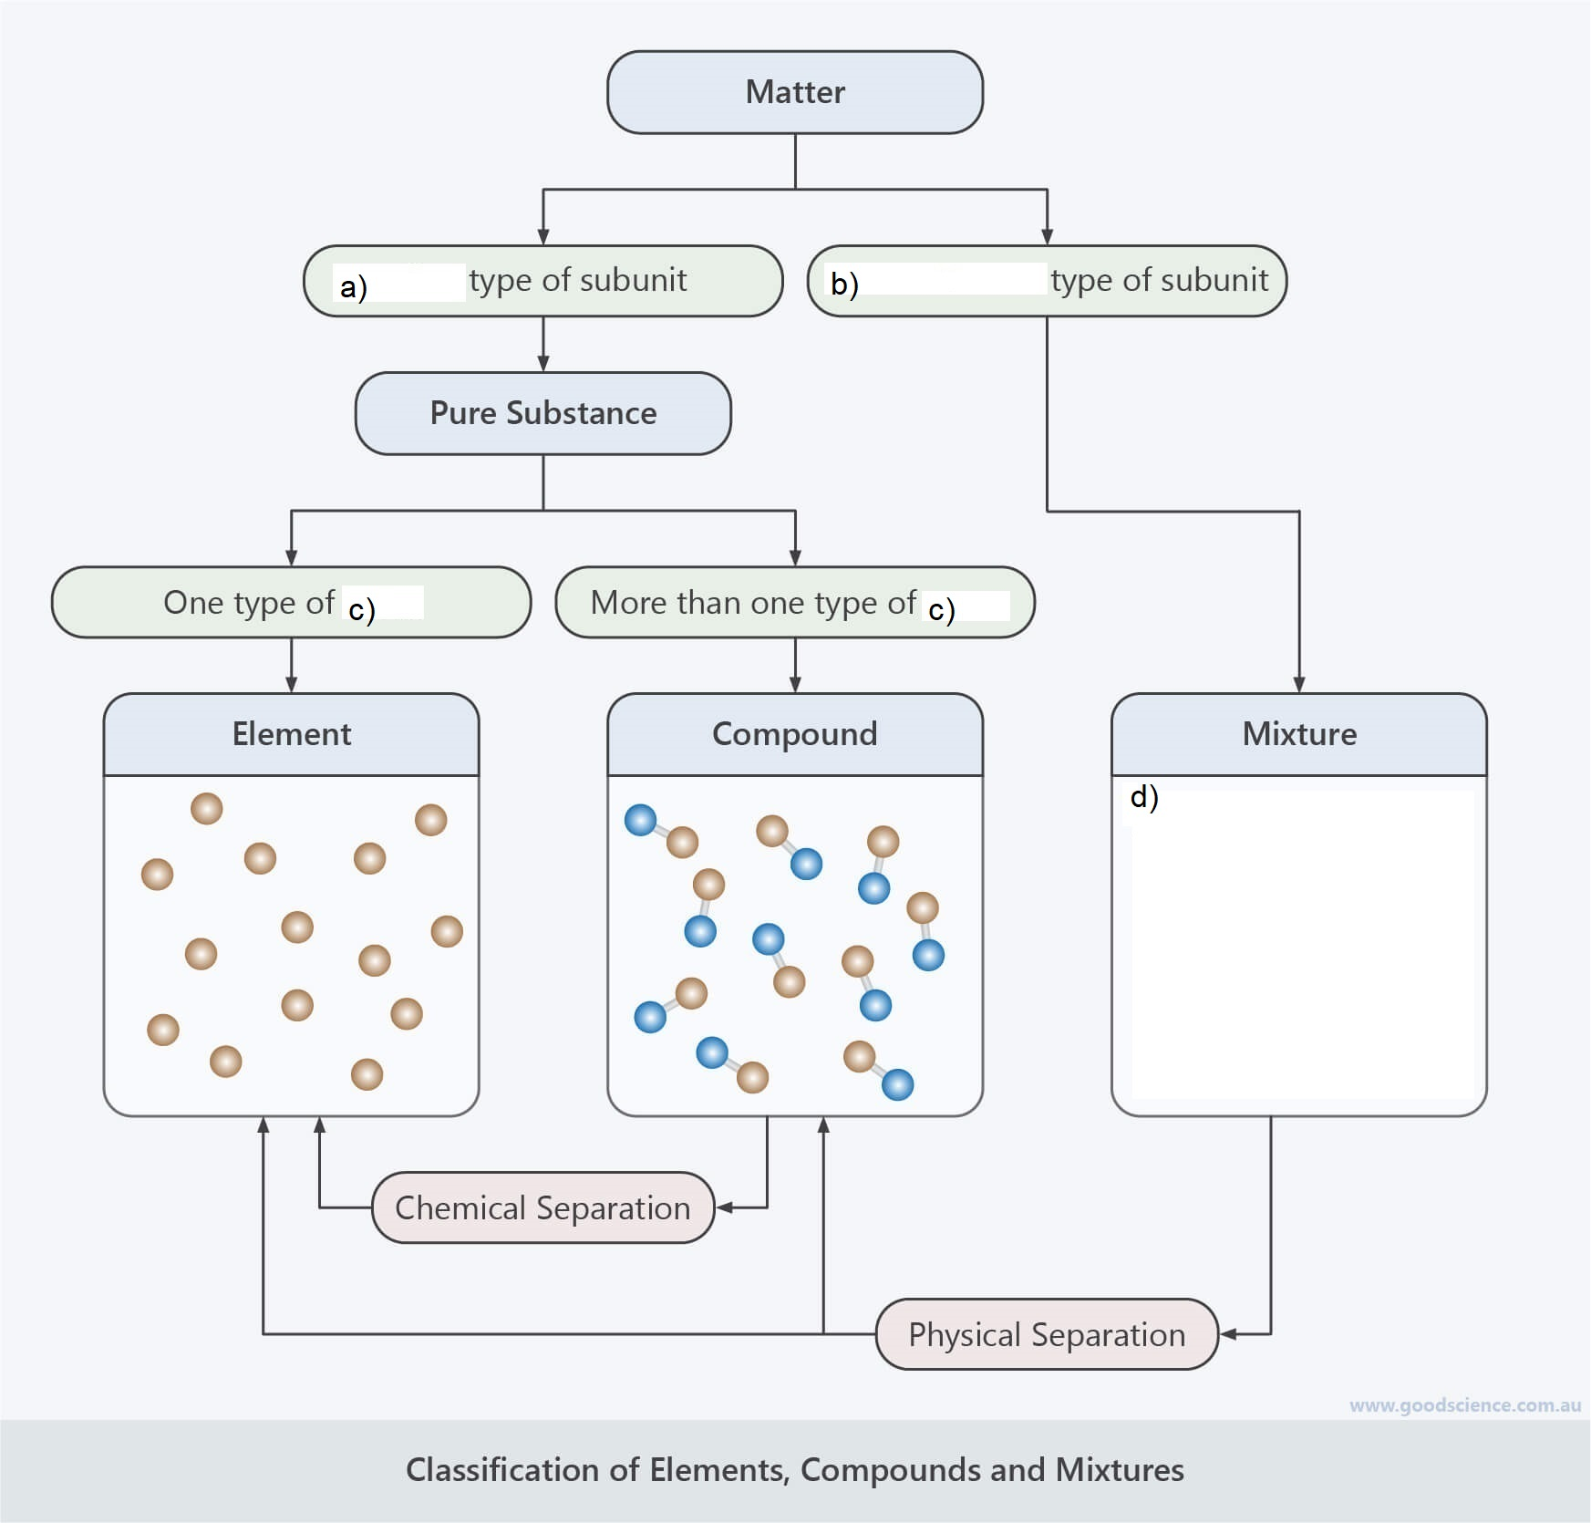Complete the below diagram that (a, b, c, d) compares the differences between pure substances and mixtures. (5 marks)

1. Identify each of the following as a pure substance or mixture by ticking the appropriate cell (5 marks)

|  |  |  |
| --- | --- | --- |
| Substance | *Pure* | *Mixture* |
| Cake |  |  |
| Sugar |  |  |
| Diamond |  |  |
| Vegetable soup |  |  |
| Aluminium |  |  |

1. Most matter on earth exists in three different states: solid, liquid and gas. Draw lines to match each state of matter to the correct description. (3 marks)

|  |  |  |
| --- | --- | --- |
| ***State of Matter*** |  | ***Description*** |
| Solid |  | Takes up a fixed amount of space, but its shape changes to match its container |
| Liquid |  | Takes up all available space,  but can be compressed |
| Gas |  | Has a definitive shape  that cannot be changed easily |

1. Are changes of state an example of physical or chemical change? Explain your answer using your knowledge of the particle model and chemical bonding. (4 marks)

____________________________________________________________________________________________________________________________________________________________________________________________________________________________________________________________________________________________________________________________________________________ ____________________________________________________________________________________________________________________________________________________________________________________________________________________________________________________________________________________________________________________________________________________

1. You find an unknown substance in your backyard that you suspect may be made of pure metal. List three (3) common properties shared by metals that you could use to check. (3 marks)
2. _________________________________________
3. _________________________________________
4. _________________________________________
5. Kevin left a frying pan outside during winter. After a few weeks of heavy rain, Kevin noticed that the pan’s surface was covered in an orange-red flaky substance.
   1. What is the orange-red substance called? (1 mark)

_________________________________________

A chemical reaction took place between the iron from the frying pan and oxygen in the air to form the substance.

* 1. Identify the reactant(s) in this chemical reaction (1 mark)

___________________________________________

1. What is the definition of a product in a chemical reaction? (2 marks)

____________________________________________________________________________________________________________________________________________________________________

1. To create energy for growth, repair, and any exercise an organism needs to do, it undergoes cellular respiration.

An incomplete word equation representing the cellular respiration with the presence of oxygen is shown below.

$$carbohydrates+oxygen→___________+___________+energy$$

1. Complete the above equation using appropriate words (2 marks)
2. What is the type of chemical reaction represented by the above equation? (1 mark)

_______________________________________

1. 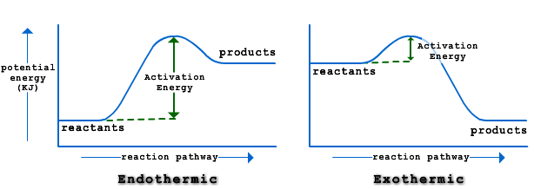Chemical reactions can either be endothermic or exothermic. With the help of the below diagram, explain the differences between the two types of reactions. (4 marks)

____________________________________________________________________________________________________________________________________________________________________________________________________________________________________________________________________________________________________________________________________________________ __________________________________________________________________________________________________________________________________________________________________________